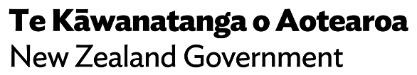
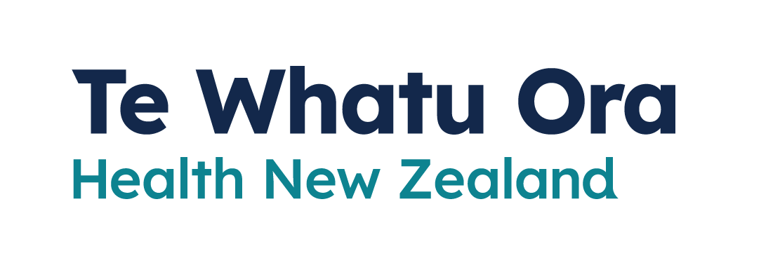
How to use a
Rapid Antigen Test
Adapted in 2023 by Accessible Formats Service,
Blind Low Vision NZ, Auckland
TN: There are two logos at the top of the page. On the left is: Te Kāwanatanga o Aotearoa New Zealand Government. On the right is: Te Whatu Ora
Health New Zealand.

How to use a Rapid Antigen Test
Rapid Antigen Tests (RATs) can be taken by yourself or under supervision.
Test instructions vary depending on the brand. Many rapid antigen testing kits generally follow the instructions below, but not all. Please follow the manufacturer’s instructions.
Rapid Antigen Test results are usually available in 20 minutes.

Collecting a sample
1. Remove a nasal swab from the pouch.
2. Insert the swab into one nostril up to 2-3cm from the edge of the nostril.
3. Slowly roll the swab 5 times over the surface of the nostril. Using the same swab, repeat this collection process in the other nostril.
4. Check the kit box instructions to confirm the correct timeframe to read your result. This may vary depending on the kit.

Testing
1. Peel off the aluminium foil seal from the top of the extraction vial, which contains the extraction buffer.
2. Place the swab into the extraction vial. Rotate the swab vigorously at least 5 times.
3. Remove the swab by rotating the swab against the vial, while squeezing the sides to release the liquid from the swab.
4. Close the vial with the provided cap and push firmly onto the vial. Mix thoroughly by flicking the bottom of the tube.
5. Turn vial upside down and hold sample over sample well. Squeeze vial gently. Allow the required drops according to the kit instructions, to fall into the sample well.
6. Please check on the kit instructions and follow the confirmed time to check for your test result.

Reading your result

Negative
One line next to the C indicates the test is negative.
If you get a negative test result and do not have symptoms, you do not need to do anything further.

Positive
Two lines, one next to C and one next to T, indicate the test is positive.

Invalid result
No line next to C indicates the test is invalid.
If a result is invalid, you must take a test again.

Reporting your results
You need to report your result. This can be done on My Covid Record.
Log into mycovidrecord.health.nz or call 0800 222 478 and press option 3.

Advice for blind, vision impaired,
low vision and deafblind people
Rapid antigen tests (RATs) can be carried out under supervision, or you can do it yourself. The result will be visible on the test itself 20 minutes after you complete your test.
All instructions for using RATs, including how to understand the results, are available on the manufacturer's website.

Supervised testing
If you need support to carry out a test or to understand the results, call Healthline on 0800 358 5453. They can help arrange either a supervised RAT at a community testing centre or participating community pharmacy, or a PCR test.

Assistance at home
If you are self-isolating and need help to understand your RAT result, we recommend you get support from a trusted friend or family member.
- Send a photo of your test result to a friend or family member to confirm the result.
- Show a friend or family member on a video call or through closed window or door.
If anybody needs to come to your place of self-isolation, make sure all health measures are being followed, including physical distancing and mask wearing.
End of How to use a Rapid Antigen Test

